***Assignment # 5***

|  |  |
| --- | --- |
| **Name** | Muhammad Asad |
| **Roll #** | 2019-EE-383 |
| **Section** | A-G1 |



***Programming Fundamentals***

**Lab # 5**

* **Objectives:**
* The First objective of this lab is to learn the logics of scanner class to take the input of our requirements.
* The main objective of this lab is to understand the deep and important concept of loops.
* **Task # 1:**

Write a program using while loop that keeps asking the user to enter a number until -1 is entered.

Then displays the number values entered, the sum of all the entered numbers and its average.

* **Code:**

import java.util.Scanner;

public class NewClass {

public static void main(String[]args){

Scanner scan=new Scanner(System.in);

int sum = 0,number,count=0;

double average;

System.out.println("enter a num");

number=scan.nextInt();

//use while loop and give a condition give in a question

while(number!=-1){

count++;

sum=sum+number;

System.out.println("sum is" + sum);

System.out.println("enter a number");

number=scan.nextInt();

}

System.out.println("count =" + count);

average=(double)(sum/count);

System.out.println("average" + average);

}

}

* **Output:**

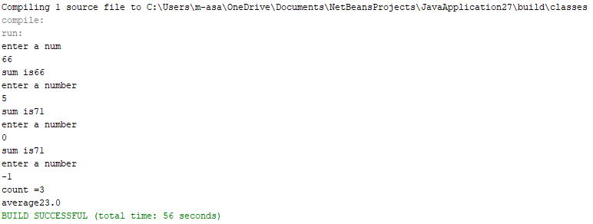

* **Task 02:**

• Write a program using while loop that asks a user to enter the total number of students enrolled in Computer Programming class.

• Then asks the user to enter the marks obtained by each student in this class.

• Display the average marks obtained.

* **Code:**

import java.util.Scanner;

public class NewClass {

public static void main(String[]args){

Scanner scan=new Scanner(System.in);

int total_student,marks = 0,sum = 0,count = 1;

double average;

System.out.println("enter a total number of students");

total_student=scan.nextInt();

Scanner mark=new Scanner(System.in);

//while condition

while(count<=total_student){

//add the marks as a loop run

sum=sum+marks;

System.out.println(sum);

System.out.println("enter a mark of "+count+" student");

marks=mark.nextInt();

count=count+1;

}

//formula of average is given below

average=(double)(sum/total_student);

System.out.println("Average marks are "+average);

}

}

* **Output:**

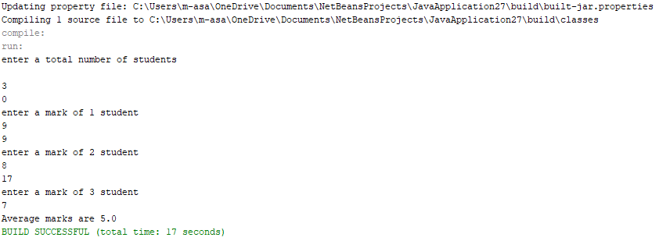

* **Task 03:**

• Write a program which computes the factorial of a positive integer using do-while loop.

• N factorial is: ! ( )( 1)( 2)....(3)(2)(1)

* **Code:**

public class NewClass {

public static void main(String[] args){

//use do while loop

int number = 5;

int factorial = 1;

int i = 1;

//do statment

do

{

factorial = factorial * i;

i++;

//while condition

} while (i <= number);

System.out.println("Factorial of " + number + " is: " + factorial);

}

}

* **Output:**

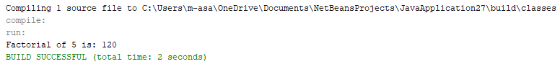

* **Task 04:**

• Write a program using do-while loop that prints the first 20 odd numbers which are not divisible by 3.

* **Code:**

public class NewClass {

public static void main(String[] args){

inti =1,count = 1;

do{

if (i%2!=0){

if (i%3!=0){

System.out.println(i);

count = count+1;

if (count==21)

//break statement is used for the stoppage of loop

break;}}

i++;}

while(i!=0);}}

* **Output:**

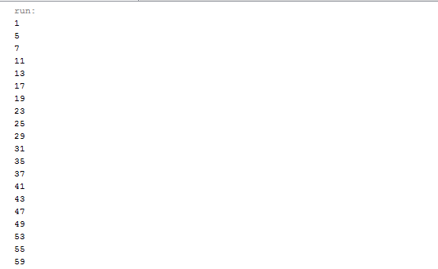

**Task 05:**

• Write a program using for loop which displays the table of entered number. (1-20).

* **Code:**

import java.util.Scanner;

public class NewClass5 {

public static void main(String[]args){

Scanner scan=new Scanner(System.in);

int a,b,c;

System.out.println("what multiplication table would you like to view");

a=scan.nextInt();

System.out.println("to what value would you like to display");

b=scan.nextInt();

//use any loop but i use for loop

for(int i=1; b>=i; i++){

c=a*i;

System.out.println(a + "x" + i + "=" +c);

}

}

}

* 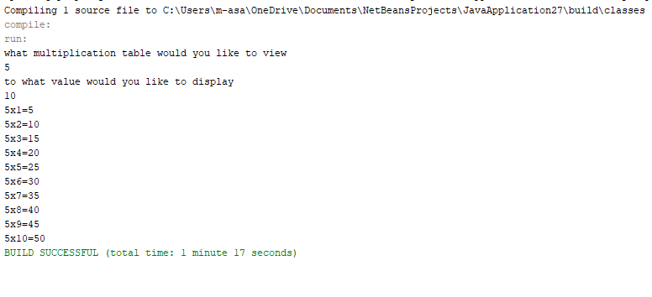**Output:**
* **Conclusion:**
* We can take the input from the user of any requirement creating a simple logic .
* Loops are very important and useful in solving mathematics problems.
* Some kinds of loops are
* For
* While
* Do

Loops are very helpful and very important in writing a code.